This program was made and tested in CLion version 2021.2.3:  
  
Using the MinGW toolchain:  
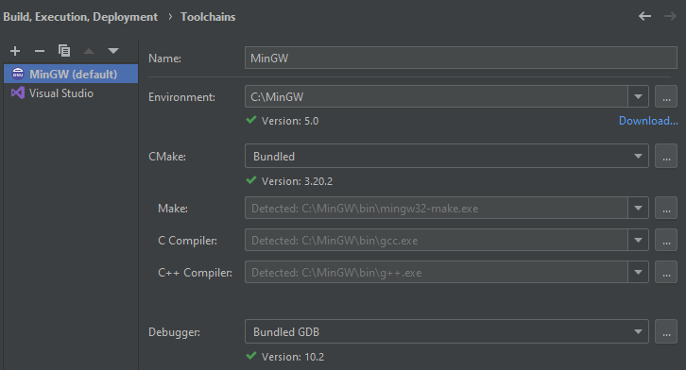

My CMakeLists.txt:

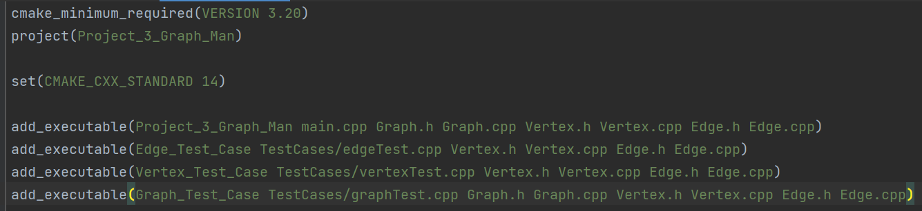

# edgeTest.cpp output:

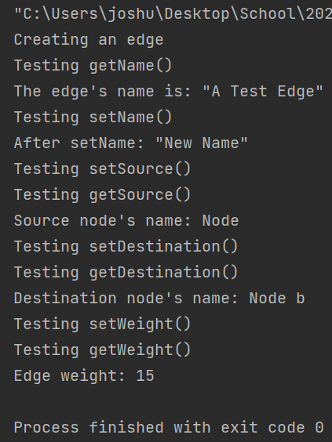

# vertextTest.cpp output:

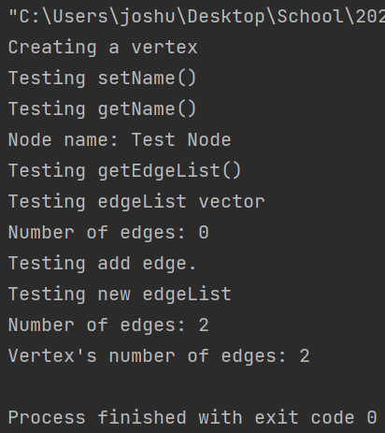

# graphTestCase.cpp output:

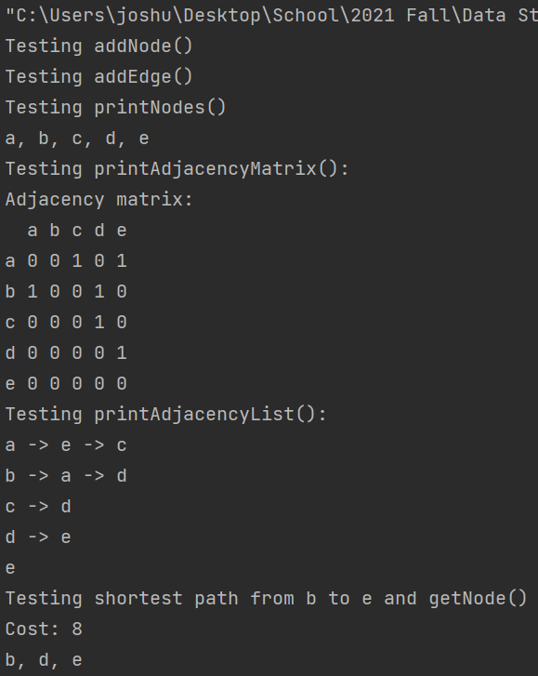

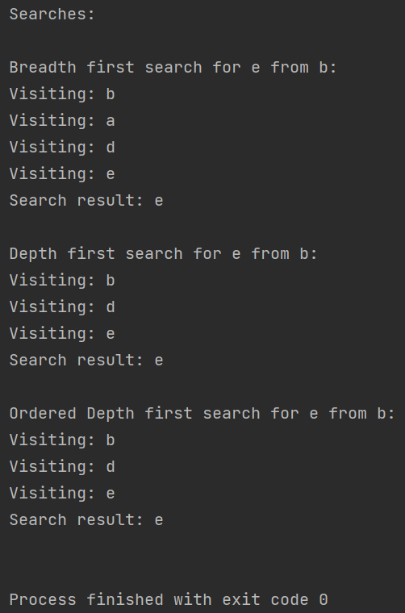

# main.cpp output:

The main menu of the program

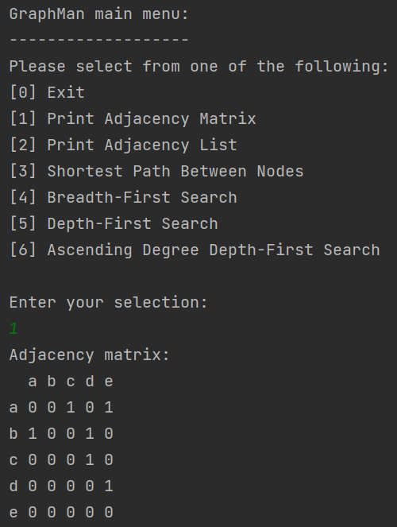  
Selection option 1 (Adjacency Matrix):



Selecting option 2 (Adjacency List):

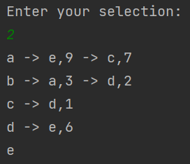

Selecting option 3 (Shortest path between 2 nodes):

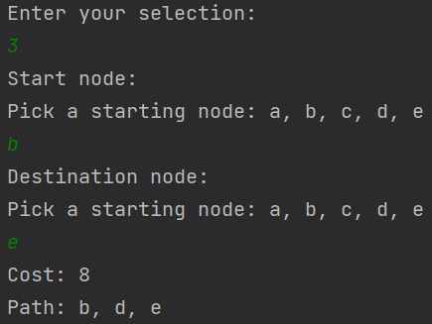

Selecting option 4 (Breadth-first search):

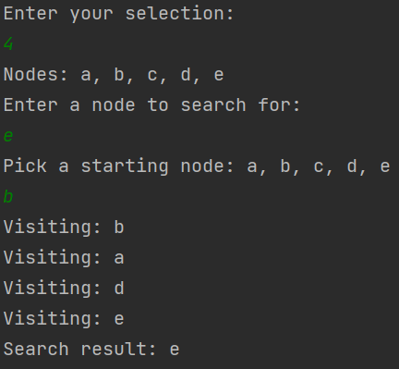

Selecting option 5 (Depth-first search):

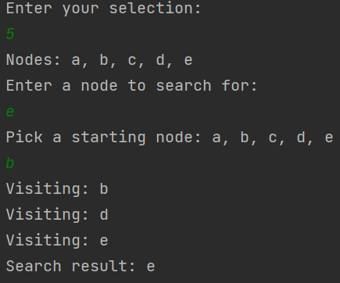

Selecting option 6 (Ordered Depth-first search):

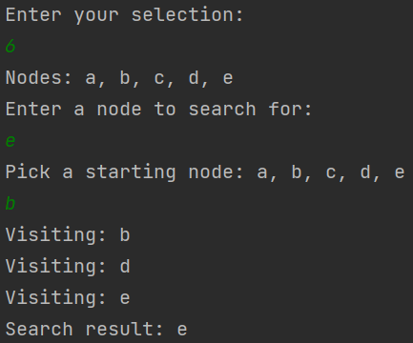

Option 6 with no path:

